Featured Speakers and Topics
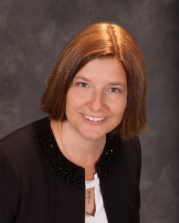
Gwen Paxon, CFRE

Legacy Giving: Embedding Planned Giving into a Holistic Fundraising Strategy
Discover how integrating legacy giving across your entire development strategy can elevate both your planned giving program and your organization’s culture of philanthropy. In this dynamic session, you’ll explore practical, creative ways to embed planned giving into every facet of your fundraising plan—annual giving, major gifts, stewardship, and beyond. Learn how a holistic, legacy-forward approach can deepen donor relationships, strengthen long-term sustainability, and align your entire team around a shared vision for impact. Join Gwen Paxon to broaden your perspective and leave with actionable strategies to infuse your development plan with a powerful, organization-wide legacy mindset.
Gwen has spent more than 20 years working in development, both on the consulting side as VP of Client Services at Catapult Fundraising and on the institutional side as Director of Annual Fund and Planned Giving. She brings a wealth of knowledge from her extensive experience to the clients and organizations she serves. Gwen has a strong ability to identify areas of opportunity and help fundraising programs reach their full potential.
Gwen holds an M.A. in Philanthropy and Development from Saint Mary’s University of Minnesota, an MBA from North Park University, and a B.S. in Public Health from Temple University. She served on the AFP Las Vegas Chapter Board for 10 years and is the Immediate Past President of the AFP–New Jersey Chapter.
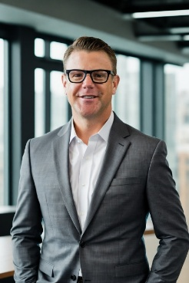
Paul Caspersen, CFP, CAP, MS, AEP

Leveraging AI in Charitable Gift Planning for 2026 and beyond
In this presentation, Paul Caspersen, CFP®, AEP®, MS will provide some updates in the dynamic evolution of AI in charitable gift planning. Participants will delve into a systematic 5-step process for analyzing charitable gifts, juxtaposed with the latest planned giving research tools. Caspersen will discuss best practices for incorporating AI and other technologies into technical planned giving research, and donor communication. Through compelling case studies, he will illustrate the successful integration of these technologies in the field. The session will be enriched by interactive dialogue, inviting audience contributions on their current use of AI in planned giving strategies. This presentation promises to furnish attendees with actionable insights.
Paul has over 27 years of expertise in financial, estate, and charitable planning and serves as the Wallace Chair of Learning and Professionalism in Philanthropy at The American College of Financial Services, where he is Director of the Center for Philanthropy. In this role, he helps shape the curriculum and strategic vision for the Chartered Advisor in Philanthropy® (CAP®) program, preparing the next generation of philanthropic advisors.
Prior to joining The American College, Paul served as Assistant Vice President and Senior Philanthropic Advisor at the University of Florida from 2012 to 2022, where he led a multidisciplinary gift planning team that secured $1.25 billion in deferred and outright gifts during the university’s $4 billion fundraising campaign.
Paul is also Founder and President of Planned Giving Interactive, LLC, developer of AI-powered planned giving research and drafting tools, and Vice President and advisor at Charitable Solutions, LLC.
He holds a Master’s in Financial Planning & Taxation and a B.A. in Business Communications.

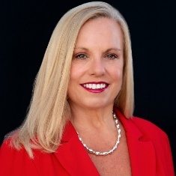
Lynn Malzone Ierardi, JD

Gifts of Non-Cash Assets
More than 90% of America’s wealth is held in assets and NOT cash. Does your organization say “no” to gifts of non-cash assets? Do you encourage your donors to consider non-cash gifts? While it’s easier in many ways to focus on gifts of cash, charities that encourage and accept gifts of non-cash assets raise more money. This fact has created a wave of interest in charitable gifts of non-cash assets. The latest tax law changes (effective in 2026) have also added to this interest as donors consider philanthropic opportunities and strategies. Both charities and donors can enjoy the benefits of a non-cash asset program that includes gifts of real estate, business interests, cryptocurrency, and more. In this session, you will hear about some unusual recent gifts, learn more about the steps you can take to build and manage a robust non-cash assets program, and position your organization to say “Yes!” to these gifts.
Lynn is a nationally recognized expert in charitable gift planning, specializing in gifts of noncash assets. She provides strategic guidance to donors, professional advisors, and charitable organizations through her firm, Gift Planning Advisor, LLC, and serves as Vice President of Real Estate Gifts with Charitable Solutions, LLC.
Lynn has strengthened gift planning programs at leading institutions including the American Heart Association, the University of Pennsylvania and Penn Medicine, and NYU Langone Health. Earlier in her career, she served as Vice President with the Merrill Lynch Center for Philanthropy and practiced trusts and estates and real estate law.
As a dedicated volunteer leader, Lynn served as 2019 Board Chair of the National Association of Charitable Gift Planners and currently serves as a member of the CGP Leadership Institute and Co-Chair of the CGP Mentor Program. She has also held leadership positions with CGP Councils in New Jersey and Philadelphia.
As a dynamic national speaker, Lynn has presented at conferences, meetings, and webinars on a variety of estate and gift planning topics—including gifts of noncash assets. One of her favorite topics is storytelling, which she explores in-depth in her book, Storytelling: The Secret Sauce of Fundraising Success.
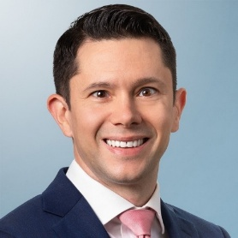
Brian M. Balduzzi, Esq., LL.M. (Tax), MBA, CFP®, CEPA®, AEP®, IPA

Feeling SECURE in Planned Giving Under the SECURE Acts and One Big Beautiful Bill Act (OBBBA)
The opportunities for charitable giving during donors’ lifetimes or at their deaths changed under the SECURE Act of 2019, SECURE Act 2.0 of 2022, and One Big Beautiful Bill Act of 2025. These changes require advisors and donors to review and strategize regarding maximizing charitable intentions. By identifying the potential benefits of using qualified retirement plans to fulfill these charitable intentions, proposing various strategic giving, and collaborating with other advisors, planned giving officers and fundraisers can maximize both the qualitative and quantitative impact for donors and charitable causes. In this session, we will discuss some of these recent changes, analyze case studies for charitable giving with these valuable retirement plan benefits, and emphasize some takeaways and language to use in your next conversations with donors and their other advisors.
Brian is an attorney in the Private Client Services Group at Faegre Drinker Biddle & Reath LLP, with offices in Philadelphia, Princeton, New York, and Chicago. He focuses on sophisticated estate and wealth transfer planning, advising clients on estate, gift, income, and generation-skipping transfer tax strategies, charitable planning, prenuptial and divorce planning, estate and trust administration, and fiduciary litigation. Brian also works with business owners and families on transitions, exits, and succession planning, and advises public charities and private foundations on governance and legal matters.
Brian is a former ABA Real Property, Trust and Estate Law Fellow and ACTEC Young Leader Fellow, and was named an ABA On the Rise – Top 40 Young Lawyers honoree. He serves in several leadership roles within the ABA RPTE Section and is active with the Philadelphia Estate Planning Council. Brian also teaches tax, estate planning, business law, and finance as an adjunct professor in undergraduate, graduate, law, and doctoral programs.
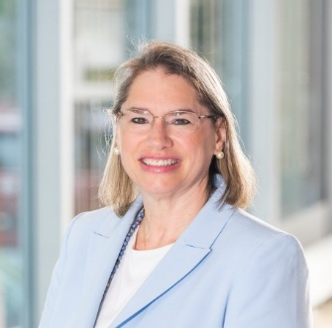
Alex P. Brovey, JD, LLM

Zen and the Art of Fundraising: The Art of Gift Planning
What qualities do successful fundraisers possess? The multitude of relationships we build with donors and colleagues is based on a critical set of skills that go beyond technical or trade expertise. These skills, which I call pillars, are ones that successful fundraisers—indeed successful people—possess and continue to hone throughout their careers. We will practice ways to begin conversations and focus on the ways planned gifts multitask, all while implementing key pillars of success.
Alex has more than 25 years of gift planning experience and serves as AVP of Gift Planning at Northwell Health Foundation, which recently completed a $1.4 billion campaign. She previously held gift planning roles at Penn State University, Pace University, and Stony Brook University, and earlier practiced estate planning law in Delaware, Pennsylvania, and New York.
Alex is a board member of the American Council on Gift Annuities, president emeritus of the Philanthropic Planning Group of Greater New York, and a past board member and treasurer of the National Association of Charitable Gift Planners. She also chairs the Leadership Institute, serves as a mentor, and is a member of the Estate Planning Council of Long Island.
A frequent national speaker, Alex lectures on a range of gift planning topics, including Zen and the Art of Fundraising, and serves on the editorial boards of Planned Giving Today and Trusts & Estates.

